Esteban Lorenzut Creative & Planning Manager
lorenzut@gmail.com
https://www.behance.net/lorenzut/ Tw: @esloren

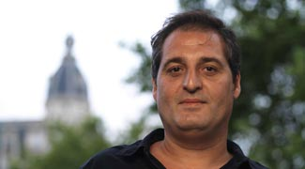

Honors and Awards 5th world ́s Executive Creative Director & 2nd World Integrated Agency according to Won Report 2009.
More than 150 awards including Cannes Lions (x5), DMA Echo Awards (x14), New York Festivals (x4), plus Caples, Golden Globe, Ojo, Wave, Mercurio, FIAP, Lápiz de Oro, Jerry Goldenberg, Amauta, Amdia, etc. including 4 Grand Prix & 6 Special Awards
Jury at Cannes Lions, Echo Awards, Caples, Clarín, Ojo, Wave, Làpiz, Diente, Amauta, Amdia, FIAP, 2 times as Jury President.
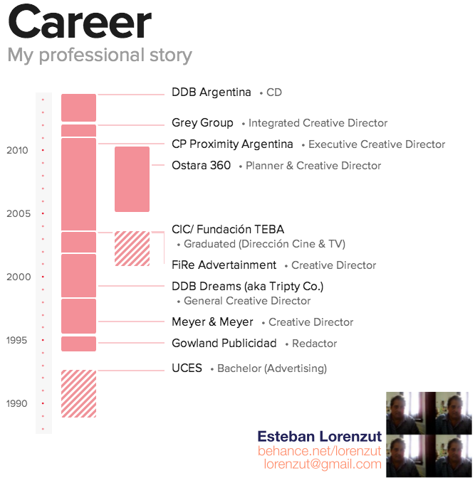
Experience
CPD Creative Planning Director at LE Boutique 2010 - Present (4 years)
CEO at MuestraGratis. https://www.facebook.com/muestragratis14 Planning consulting / Creative freelance for agencies & production houses as Ostara, Mutis, Rapp, WebAr, Cannes Chimera, pornhub.net

Integrated Creative Director DDB Argentina/ Tribal 2012 - 2014 (2 years)
Procter & Gamble, Unilever, BBVA, McDonald´s, Gillette, Pampers, Clorox,

Integrated Creative Director Grey Group/ Oct 2010 - Nov 2011 (1 year 2 months)
CD for Procter & Gamble mainly. Have developed activations on & off line and even direct, general ad campaigns for Pantene, Pringles, Eukanuba, Herbal Esences, Playboy, GSK, Biopiscinas, La Anónima

Executive Creative Director at CP Proximity May 2003 - October 2010 7years leading an independient integrated project that becames the 2nd World's agency.
Works at planning & creative to direct, digital, general ad, Promo and integrated projects for Telecom, Arnet, arnet.com.ar, Gas Natural, diario El País, Wines of Argentina, Banco Privado, WAPI, Coca-Cola, Personal, Banco de Galicia,

Planner & Creative Director at Ostara 360 2005 - July 2010 (5 years)
Have collaborated with the launch, developing & formatting of the agency departments for Personal, BlackBerry, SAP, Santander Río, Bodegas Orfila, YPF, etc

Creative Director at FiRe Advertainment August 2001 - May 2003 (1 year 10 months)

General Creative Director at DDB Dreams (aka Tripty Co.) February 1998 - July 2001 (3 years 6 months) works in Digital & Direct campaigns for Telefonica, Speedy, BankBoston, ScotiaBank, Sheraton Hotels, etc
Creative Director at Meyer & Meyer May 1996 - February 1998 (2 years)
Promo & Direct for Visa, Ford, Previnter, BankBoston, 1784 Founds, La Caja, BNL, etc
Redactor at Gowland Publicidad, Ratto BBDO, M&M, Radio Mitre/FM 100. 1994 - 1996 (1 year)
Publications
Introd. a la Clase B Ed. Corregidor 1996 Premio Estimulo Fondo Nacional de las Artes
Eterna Tertulia Ed. Dunken 2000
Education UBA Master's degree, Marketing Interactivo, 2012 - 2012
CIC/ Fundación TEBA Graduated, Dirección Cine & TV, 2000 - 2003
UCES Bachelor, Advertising, 1988 - 1992
Courses DDB Argentina Catalyst for Coachers 2013- Social Media Strategic 2012/3- UBA Marketing Interactivo 2012- WPP Shopper MKT 2011- DMA Creative Strategic 2008
Languages English Portuguese Spanish
Volunteer Experience Creative at Médicos Sin Fronteras (MSF)- Fundación Sales- Varias ONG

